
National University of Science and Technology POLITEHNICA Bucharest

SUMMARY
DOCTORAL THESIS

Evolution of conditional processing characteristics for beta-type titanium alloys placed at the metastable frontier

Author. Raluca-Elena IRIMESCU
Scientific supervisor: Prof. dr. eng. Doina RĂDUCANU

INTRODUCTION.....................................................................................................3
1. Motivation for choosing the research topic003
2. Importance, novelty and topicality of the topic.................................................................5
3. Framing the theme in the national and international concerns of the research team.................................................................................................................5
4. Formulating the research hypothesis006
5. Scientific objectives for resolution in scientific research006
6. Summary comments on research method and research methodology.......7
7. Brief presentation of the content of the work, highlighting the results obtained008
- Theoretical and practical limitations ................................................................................11
- Developments............................................................................................................................11
10.General conclusions ............................................................................................12
10.1 General conclusions on the achievement of the scientific objectives proposed in the PhD thesis................................................................................................................12
10.2 The problems proposed for research and the prospects opened by it/ advantages/disadvantages...........................................................................................................13
10.3 Issues considered partially unresolved............................................................14
11. Own contributions in the scientific field of the doctoral thesis .....................................15
11.1 Measurable own contributions...........................................................................15
11.2 Future directions for scientific research..............................................................21
BIBLIOGRAPHY....................................................................................................................22

INTRODUCTION
- motivation for choosing the research topic ;
Titanium alloys, valued for their outstanding strength to weight ratio, corrosion resistance and thermal stability, are optimized through complex alloying processes to meet the stringent requirements of critical applications in aerospace, medical, automotive, energy and other critical industries.
In the medical field, which is the subject of this PhD thesis, titanium has established itself as one of the most widely used metals. Thanks to its bioineration, it does not react with the body's internal environment, making it the main choice for applications such as dental implants, orthopedic rods, bone plates and other prostheses. Titanium is also used in the manufacture of a wide range of medical instruments.

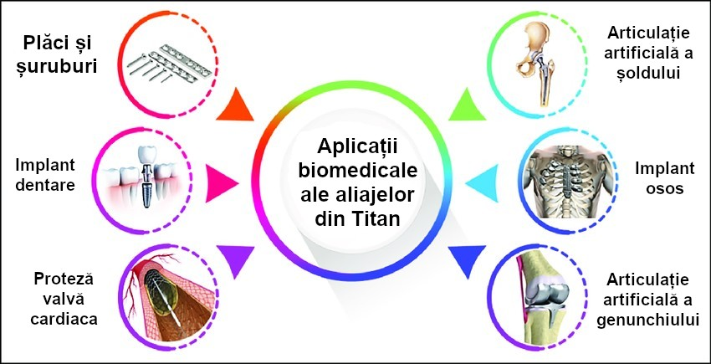

Figure 1. Biomedical applications of titanium alloys [137].

In medical applications, the inclusion of alloying elements is crucial for adjusting the properties of titanium alloys according to specific requirements. Depending on their effect on the β-transus temperature, these elements fall into three categories: neutral, α-stabilizing and β-stabilizing.

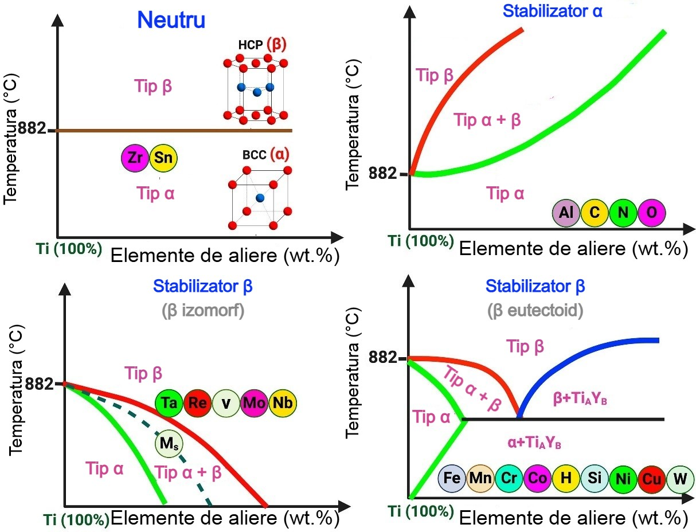
Figure2 .(a) hcp (alpha) and bcc (beta) structure of titanium. (b) Phase diagram categories of titanium formed with different alloying additions [14,97 ,103].
In pure titanium, the transition from the α-phase to the β-phase occurs by allotropic transformation when the α-phase is heated up to the β-transus temperature (882 °C). This temperature is influenced by the purity of the titanium, and the addition of alloying elements in titanium alloys significantly affects the transformation temperature.
By understanding the role of alpha, beta and neutral stabilizing elements, chemical compositions can be optimized so that alloys can achieve superior mechanical properties, increased corrosion resistance and improved machinability. In addition, the proportion of alpha, beta and other phases in a given alloy is influenced by the mechanical and thermal processes applied, having a significant impact on material characteristics such as mechanical strength, hardness, creep properties, ductility, weldability and ease of machining.
Thus, two types of interventions are essential in the design of titanium alloys adapted to the requirements of medical applications:
- Choosing an optimal chemical composition;
- Defining appropriate mechanical and thermal processes that influence the structure of the alloy and hence its properties.
Both aspects were taken into account in the development of the experimental scientific research program presented in the PhD thesis.
- Importance, novelty and topicality ;
In the field of medical applications, the use of metastable beta-type titanium alloys represents an innovative approach. These alloys (including near-beta) undergo mechanical and thermal processes to achieve the desired microstructure, phase volume fraction and specific characteristics required for each application.
By optimizing the mechanical and thermal processing, metastable beta-type titanium alloys can be transformed into forms suitable for medical use, while allowing microstructure control to improve the functional properties required in this field.
Of the beta-metastable titanium alloys, the TNZT alloying system has not been sufficiently investigated in terms of the correlation between processing, structure and properties.
There are a few studies in the recent literature, but most of them mainly focused on the biocompatibility of these alloys. The complex relationships between processing, structure and properties of TNZT titanium alloys are not adequately and explicitly addressed in existing sources. According to the most recent research [14], "further studies are needed to evaluate the characteristics required" for their use in medical applications.
Thus, the PhD thesis investigated the field of biocompatible, beta metastable TNZT titanium alloys by developing an alloy with a novel and original chemical composition. It was subjected to mechanical and thermal processing using alternative processing routes specifically designed for the specific characteristics of the realized alloy.

- The framing of the theme in the national and international concerns of the research team ;
Recent data in the scientific literature show that titanium alloys with a MoE index value of about 10.00 are very little investigated. In the case of the expected chemical composition, the TNZT-O alloy studied in the experimental program of the PhD thesis has a MoE value of 10.88, which is close to the conventional lower limit of the metastable range.
This approach to the conventional limit can be considered as an area of uncertainty, which is worth exploring to clarify the characteristics of this type of titanium alloys.
Through its content and the scientific results validated by the published articles, the PhD thesis contributes organically to the research team's concerns on the development of biocompatible titanium alloys for medical applications.

- Formulating the research hypothesis ;
Within the experimental program of the PhD thesis, a new and original composition of a metastable beta-type titanium alloy from the TNZT-O system was synthesized, having the formula Ti-36,5Nb-4,5Zr-3Ta-0,16O.
This alloy includes an addition of oxygen, which differentiates it from other TNZT compositions. The motivation and impact of the oxygen addition on the alloy's performance as a biocompatible material are detailed in the PhD thesis.
For the newly developed alloy, the field of mechanical and thermal processing at super-transus temperatures was systematically explored, using rolling as the main plastic deformation method.
At present, there are a small number of studies investigating plastic flow behavior as a function of processing parameters at both super-transus and sub-transus temperatures for metastable beta and near-beta beta titanium alloys.
The experimental program developed in the PhD thesis was designed to evaluate and explain the behavior of the TNZT-O alloy as a function of processing parameters, applying a uniform approach by processing exclusively at super-transus temperatures for the new near-beta/metastable TNZT-O alloy. It was considered that the concurrent analysis of sub-transus temperatures, together with the large number of experimental coordinates and the extensive volume of investigations, would not have brought significant clarifications on the studied aspects if it had been performed only under certain experimental conditions without an in-depth investigation. Investigations on TNZT-O alloy at sub-transus temperatures represent a separate direction of scientific research, requiring a separate effort at a later stage of development.

- Scientific objectives for resolution in scientific research ;
The main objective is to extend the knowledge of how the microstructure of beta alloys, in particular TNZT-O, changes at the metastable boundary, by thermal and mechanical processing (plastic deformation), and the impact of these changes on the development of structural and mechanical characteristics.

Specific objectives
- Investigation of the correlation between the primary processing of the alloy in the super-transverse field and the secondary processing also in this field.
- Realization of secondary processing of TNZT-O alloy in the super-transverse range under varying heating temperature and holding time conditions.
- Determination of the most efficient combination of mechanical processing (by plastic deformation) and thermal treatments (quenching and solution annealing), able to control recrystallization processes and the modification of the β/α″ phase volume fraction.
- To identify and analyze the phenomena and transformations occurring during each processing step, in order to contribute to the clarification of some still misunderstood aspects related to the behavior of β-type titanium alloys at the metastable frontier.
- Obtain appropriate combinations of constituent phases and microstructures for the TNZT-O alloy to give it characteristics suitable for use in medical applications.
- Summary comments on the research method and research methodology ;
The chemical composition of the studied alloy was analyzed using the EDS method, using a TESCAN VEGA II e XMU (Tescan - Czech Republic) electron microscope, equipped with a BRUKER Quantax xFlash 6/30 EDS detector. This method (EDS) was also used to evaluate the element distribution (homogeneity) on the surface of the samples. The identification of the phases in the TNZT-O alloy, during the different processing steps, was carried out by X-ray diffraction (XRD), using a RIGAKU MiniFlex600 diffractometer (RIGAKU - Japan), in the 2θ range of 30° - 90°, with Cu-Kα radiation (λ~1.54 Å), with detection limits between 0.1 and 1 mass/phase %. For mechanical characterization, tensile tests (tensile strength, yield strength, elongation, elongation, modulus of elasticity) were performed using a GATAN MicroTest-2000N (Gatan Inc. - USA) tensile-compression test module, mounted on the TESCAN VEGA II e XMU electron microscope.
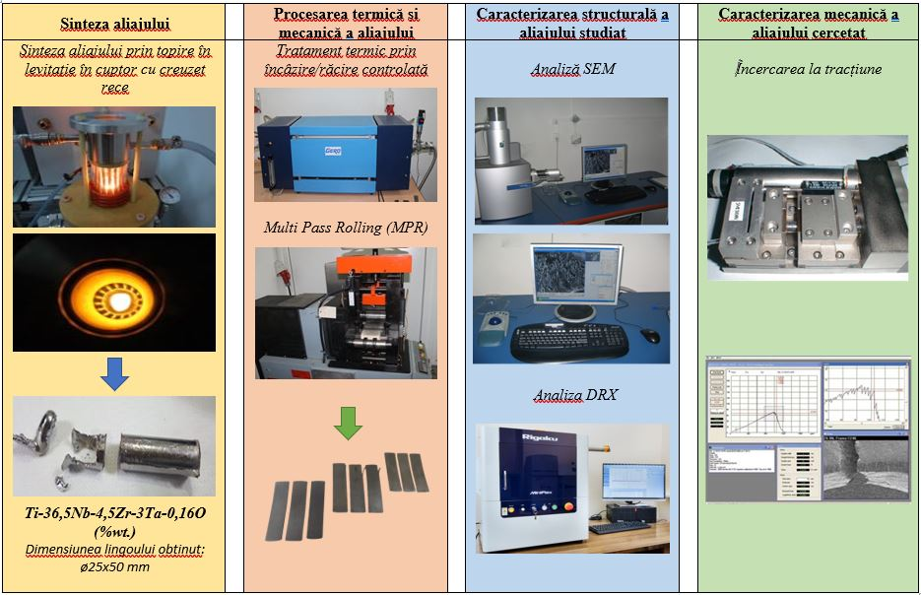
Figure 3. Schematic representation of the processing steps and investigation methods in the experimental program carried out in the PhD thesis

- Brief presentation of the content of the work, highlighting the results obtained ;
Chapter 1 of the PhD thesis explores the specific phenomena and transformations of titanium alloys as influenced by processing methods. It presents a general classification of titanium alloys, the physical and mechanical properties of titanium, as well as its applications in various industrial fields including biomedical and aerospace.
Titanium is a metal with low density, high mechanical strength, excellent biocompatibility and corrosion resistance. These properties make it ideal for uses in implantology, aerospace and chemical processing. The study analyzes the allotropic structure of titanium, its α and β phases, and how they are influenced by alloying elements.
The main types of titanium alloys are highlighted: alpha (α), alpha-beta (α+β) and beta (β). β alloys are considered the most promising for biomedical applications due to their low elasticity mode and superior fatigue strength. Titanium phase stabilizers, such as aluminum, vanadium and molybdenum, which influence the structural transformations and mechanical properties of the alloys, are also discussed.
Thermomechanical processing plays an essential role in optimizing the properties of titanium alloys. Hot and cold rolling, heat treatments and plastic deformation determine the microstructure and final mechanical performance. Studies indicate that appropriate heat treatments can considerably improve the mechanical strength and hardness of titanium alloys.
The chapter concludes with a review of the applications of titanium alloys in the biomedical field, where they are used for orthopedic and dental implants, and in the aerospace industry, where they are essential due to their high strength-to-weight ratio and optimal behavior at high temperatures. The research presented highlights the importance of processing methods and chemical composition in determining the performance of titanium alloys for various industrial uses.

Chapter 2 of the PhD thesis focuses on the study of biocompatible beta titanium alloys with medical applications due to their unique combination of mechanical properties, biocompatibility and corrosion resistance. The work explores metastable beta alloys, with a focus on TNZT (Ti-Nb-Zr-Ta) alloys, to which oxygen is added to improve mechanical and structural characteristics.
The experimental program developed in the thesis investigates the chemical composition, phase stability and mechanical properties of a new thermomechanically processed TNZT-O alloy. The influence of temperature and heat treatments on the structure and performance of the alloy is investigated. The processing includes hot and cold plastic deformation, rolling, quenching and ageing treatments, as well as microstructural analysis by advanced techniques such as SEM, XRD and EDS.
The paper highlights the importance of optimizing the ratio of beta-phase stabilizers and processing parameters to obtain an alloy with superior properties. The study compares the new TNZT-O alloy with other titanium alloys used in implantology, highlighting its advantages, including an elasticity modulus close to that of human bone, thus preventing stress shielding. The correlations between the chemical composition, microstructure of the final result and mechanical performance are also detailed, demonstrating the viability of TNZT-O alloy for use in medical implants.
Through the detailed investigation of the influence of alloying elements and thermomechanical processing, the thesis makes original contributions in the field of beta titanium alloys, proposing an innovative and optimized composition for biomedical applications. It represents a step forward in the understanding of the behavior of metastable beta alloys, with practical implications in the development of advanced materials for implantology and other medical applications.

Chapter 3 of the thesis presents experimental investigations on the processing and characterization of TNZT-O titanium alloy. The alloy was obtained by cold crucible furnace melting, ensuring a uniform composition and fine microstructure. The mechanical and thermal processing included hot and cold rolling as well as solution quenching treatments, influencing the microstructural and mechanical properties.
The structural characterization was performed by X-ray diffraction (XRD) and electron microscopy (SEM, EBSD ), highlighting phase and grain changes as a function of processing. Mechanical analysis by tensile tests showed that certain processed states provide an optimal balance between mechanical strength and low modulus of elasticity, essential for medical applications.
In conclusion, the research demonstrated that proper processing can optimize the properties of TNZT-O alloy, making it a promising candidate for biomedical use.

Chapter 4 of the thesis analyzes the evolution of the characteristics of TNZT-O titanium alloy as a function of mechanical and thermal processing. The study aims to identify an optimal machining process for medical applications, with the objective of obtaining a high yield strength while maintaining adequate ductility and a low modulus of elasticity. The alloy processing involved plastic deformation followed by heat treatments at varying temperatures near or above the transus temperature.
The microstructural investigations were performed by X-ray diffraction (XRD) and electron microscopy (SEM, EBSD), highlighting the phase evolution and grain distribution according to the processing steps. The analysis included initial structural states, plastic deformations (hot and cold rolling) and solution heat treatments. The results showed that cold rolling favors the emergence of the martensitic α′′ phase, while heat treatments influence recrystallization and microstructural homogenization.
Mechanical properties were evaluated by tensile tests, determining yield strength, ultimate tensile strength, modulus of elasticity and elongation at break. The evolution of these characteristics revealed three structural states with optimal performance for medical applications: S1.3 (641 MPa, 52 GPa), S1.2 (644 MPa, 58 GPa) and S2.1 (636 MPa, 58 GPa).
In conclusion, the study demonstrates that mechanical and thermal processing significantly influence the characteristics of TNZT-O alloy, and certain combinations of treatments offer promising properties for use in medical implants. Oxygen, as an interstitial element, contributes to the hardening of the β-matrix, and proper control of the processing allows an optimal balance between mechanical strength and elasticity.

- Theoretical and practical limitations
  - Theoretical limitations concern the evaluation of the MoE parameter and the β-transus temperature.
According to the established classification, the MoE parameter value for metastable beta titanium alloys is between ~10.0 and ~30.0 with the caveat that a MoE parameter value of about 10.0 is required to stabilize the β-phase (cvc).
The TNZT-O alloy investigated in the experimental program carried out in the PhD thesis has a MoE value of 10.88 for the expected chemical composition. Compared to the conventional MoE=10 value used in the established classification and taking into account the relativity of this classification, the studied alloy is considered to be placed at the beta metastable frontier. It becomes all the more interesting to study it in order to make further contributions exploring these neighborhoods of the conventional classification boundary.
The transition temperature α → β, referred to as β-transus temperature, is a particularly important parameter for determining the plastic deformation processing temperatures and heating temperatures for various heat treatments envisaged in various mechanical and thermal processing schemes, possibly applicable for titanium alloys.
If the transition temperature α → β is determined theoretically, there are formulas to evaluate this parameter. It has been found that the application of these computational relations yields very different results, the differences being on the order of tens of degrees Celsius.
  - Practical limitations
Within the experimental program carried out during the doctoral training period, two aspects of practical nature have set two limits to the experimental research carried out; the motivation is related to the type of equipment available in the doctoral school laboratories which made it difficult to directly evaluate the experimental methods for :
- β-transus temperature determined by experimental means; no such equipment is available in the laboratories;
- identification of the phaseα ": the type of electron microscope (SEM) in the laboratory's equipment does not allow, in the particular case of the present phaseα ", its identification.

- Developments
It was considered that, within the experimental program of the PhD thesis, the exploration at both super- and sub-transus temperatures would have led to a significant increase of the experimental coordinates and the volume of investigations, without bringing sufficient clarification of the studied aspects, if it would have been carried out only in certain experimental coordinates without a thorough analysis. Given the magnitude of the investigations required, the study of TNZT-O alloy at sub-transus temperatures represents a distinct research direction that will require additional effort in a future stage of development.
- General conclusions

10.1 General conclusions on the achievement of the scientific objectives proposed in the PhD thesis
The experimental research carried out through the development of the experimental program developed within the PhD thesis proves the clear framing of the research in the field of doctoral studies, field: Materials Engineering
The content and results of the scientific research carried out in the doctoral thesis highlight contributions and elements of originality and prove the achievement of the scientific objectives proposed in the doctoral thesis:
- Synthesis of a new, original, beta-metastable titanium alloy composition of the TNZT-O system, namely Ti-36,5Nb-4,5Zr-3Ta-0,16O.
- the alloy has in its composition also an addition of oxygen, so the final compositional type of the investigated alloy is TNZT-O which differentiates it from other TNZT-type compositions; the motivation and contribution of the oxygen addition reflected in the performance of the alloy as a biocompatible material was presented in paragraph 2.3.1;
- for the new alloy realized in the PhD thesis, the field of mechanical and thermal processing for super-transus temperatures is explored in a systematic way, using for the mechanical processing, plastic deformation by rolling;
- an original mechanical and thermal processing procedure has been devised, carried out through plastic deformation steps by rolling, combined with homogenization/ solution hardening heat treatments
- the most efficient combination of mechanical (plastic deformation) and thermal (solution annealing heat treatments) processing was determined to give the investigated TNZT-O alloy suitable characteristics for use in medical applications;
Methods of scientific validation of the scientific results obtained from the experimental program carried out in the framework of the PhD thesis
The tests carried out in the advanced characterization investigations for each structural state resulting from the experimental program took into account the repeatability and reproducibility of the results.
As a result of the experimental program carried out to achieve the objectives of the PhD thesis, a number of scientific results were selected for dissemination; thus, four scientific articles (presented in detail in the List of papers and in full) were published in peer-review system.
The acceptance and publication of articles containing scientific results obtained in the experimental program and the PhD thesis in ISI indexed journals validates the scientific results obtained in the PhD thesis.

10.2 Problems proposed for research and the prospects opened by it/ advantages/disadvantages
The main difference between nearly beta, beta-rich, stable and metastable titanium alloys lies in their phase stability and microstructural behavior at room temperature and after thermomechanical processing. This difference is directly related to the alloy composition and the concentration of beta-phase stabilizing elements (e.g. molybdenum, vanadium, chromium, etc.).
The type of martensitic phase (α' or α'') depends on the stability of the beta phase, which is influenced by the composition of the alloy, in particular molybdenum equivalence ( MoE ):
Low MoE: promotes martensite α' (HCP ).
Intermediate MoE: leads to α'' (orthorhombic) martensite.
High MoE: stabilizes the beta phase, suppressing martensitic transformation.
The ability to increase the mechanical strength of a beta metastable or near-beta titanium alloy during solution heat treatment followed and/or not by aging heat treatment is related to the instability of the β cvc phase at temperatures below the beta transus.
An important characteristic of beta titanium alloys is the possibility to modify the modulus of elasticity over a fairly wide range of values by changing the chemical composition and/or also by various versions of mechanical and thermal processing that can modify the volume fractions of constituent phases with effects on the modulus of elasticity values.
These alloys will usually have a β-phase matrix with primary α-phase grains and also secondary α-phase particles that are usually formed as a result of mechanical and thermal processing.
As a rule, after primary processing, large crystalline grains of beta type with possibly alpha phase placed at the crystalline grain boundary result in continuous or fragmented crystalline grains in the form of segments.
A significant purpose of processing would also be to prevent or limit the formation of continuous α-phase along β-phase grain boundaries [30]. This morphology would have a detrimental effect on some mechanical properties, especially in the case of large β-phase crystalline achiaxial crystalline grains.
A separate discussion is related to the presence of oxygen in the chemical composition of the realized alloy. Oxygen has limited solubility in the beta phase, and excessive amounts can segregate at grain boundaries, potentially affecting ductility and toughness. It acts as an interstitial strengthening agent. It also significantly increases the strength of beta titanium alloys by distorting the lattice structure and preventing dislocation movement. This effect is beneficial for applications requiring high strength. While oxygen improves strength, it reduces ductility, toughness and fatigue resistance due to increased brittleness. Maintaining controlled oxygen levels is essential to balance these properties. For example, beta metastable alloys with higher oxygen content may exhibit reduced elongation to fracture.
Oxygen affects the kinetics of martensitic transformations and the precipitation of the secondary alpha (α") phase during heat treatments or aging. It can increase transformation temperatures and favor the formation of fine alpha precipitates in the beta matrix, which increases strength but reduces ductility. It may also influence grain finish by affecting recrystallization behaviour during thermomechanical processing.

10.3 The aspects considered partially unresolved are related to some practical limitations related to the type of equipment available in the laboratories of the doctoral school that made it difficult to directly evaluate, by experimental methods, the β-transus temperature determined by experimental means and to identify the phaseα " (the type of electron microscope (SEM) in the laboratory does not allow, in the particular case of the present phaseα " its identification).
From the point of view of the transformations taking place in the studied alloy, in the case of the S2.3 structural state it was difficult to find a satisfactory explanation for the presence of α′′′ martensite; this is a currently unresolved issue that requires further investigation in future work.

11. Own contributions in the scientific field of the doctoral thesis

11.1 Measurable own contributions

11.1.1 The PhD thesis investigated the field of biocompatible TNZT beta metastable biocompatible alloys by realizing an alloy with a new/original chemical composition, mechanically and thermally processed by alternative processing routes specifically designed for the realized alloy. Thus, an original, hitherto unstudied chemical composition was established with niobium, zirconium and tantalum as alloying elements; in addition to these, an oxygen addition was used;
The expected chemical composition of the TNZT-O type alloy before melting/synthesis of the alloy is (Chapter 2/Section 2.3.1):
Ti-36,5Nb-4,5Zr-3Ta-0,16O

11.1.2 Another important aspect of the results obtained is related to the addition of oxygen, whose strong influence on interstitial hardening is reported in numerous papers [54-57]. If the comparison previously made with some alloys having similar compositions and processing methods is analyzed, it can be stated that the presence of oxygen can indeed increase the β-matrix strength: the examples of alloys in (a) and (b), without oxygen, have lower values for the ultimate strength and higher values for the modulus of elasticity compared to those containing reduced amounts of oxygen. Even the currently studied alloy fits this objective by the obtained values of the mechanical characteristics (Chapter 4/Section 4.3)
11.1.3 For the chemical composition of the TNZT-O alloy realized and studied in the framework of the PhD thesis, the calculation for the determination of the MoE parameter was carried out and obtained:

MoE = 0.28 (36.5% Nb) + 0.22 (3% Ta) = 10.88

According to the conventional classification it can be observed that the value MoE=10.88 obtained for the studied alloy places it at the lower limit of the metastable boundary, for which the reference value is MoE=10.00; it was previously stated that the delimitation of titanium alloy types according to the MoE index value is not necessarily absolute (Chapter 2/paragraph 2.3.2).
11.1.4 The polynomial linear regression method was used to calculate the β-transus temperature; this resulted in a β-transus temperature equal to 706.5°C (Chapter 2/Section 2.3.3)
11.1.5 The experimental program developed in the PhD thesis was carried out to evaluate and explain the behavior of the TNZT-O alloy as a function of processing parameters using a homogeneous approach by processing only at super-transus temperatures for the new near-beta/metastable TNZT-O alloy. Nine structural states resulted as follows:
- S1/ Initial condition/ molded ingot;
- S2/ Hot deformed plastic/950°C/ε=42.5%;
- S3/ Solution Heat/ 820°C/30 min/water;
- S4/ Cold plastic deformed /ε=30.5%;
- ST1.1/ Solution Quench/ 780°C/10 min/water;
- ST1.2/ Solution Quench/ 780°C/20 min/water;
- ST1.3/ Solution Quench/ 780°C/30 min/water;
- ST2.1/ Solution boiling/ 830°C/10 min/water;
- ST2.2/ Solution Quench/ 830°C/20 min./water;
- ST2.3/ Solution Quench/ 830°C/30 min./water;
(Chapter 2/paragraph 2.3.4).
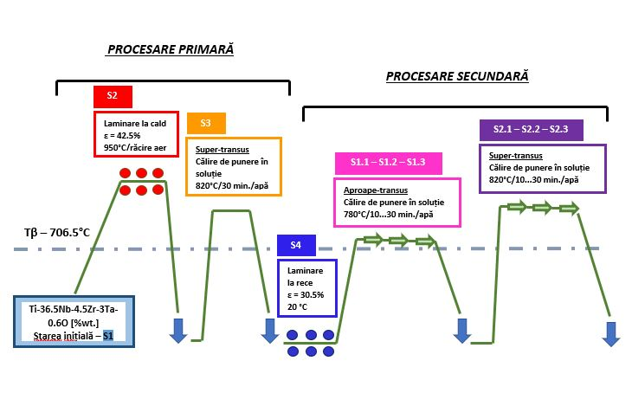
Figure 4. - Schematic of mechanical and thermal processing of Ti-36,5Nb-4,5Zr-3Ta-0,16O alloy (weight %)

11.1.6 The best processing version of TNZT-O titanium alloy is the ST1.3 investment state (780°C-30 min-CA) which is determined on the basis of an optimal combination of mechanical strength (Rm 641 MPa) and low modulus of elasticity (Modulus of elasticity 52 GPa), essential for medical applications.
(chapter 4/paragraph 4.3).
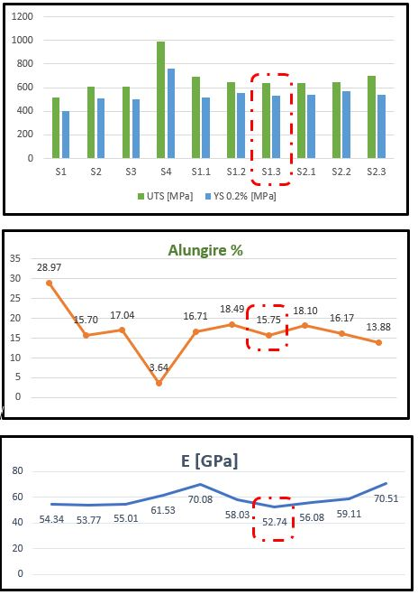
Figure 5. - Evolution of the mechanical properties for the studied alloy at all stages of the experimental program: (a) ultimate tensile strength [MPa] - Rm; yield strength [MPa] - (Rp0.2); (b) elongation at break (%) - ε; (c) modulus of elasticity [GPa] - E.
11.1.7 For the best processing version of TNZT-O titanium alloy, ST1.3 condition (780°C - 30 min - AC), the structural characteristics are as follows:
- Homogeneous microstructure with small equiaxial crystalline grains, which contributes to a low modulus of elasticity and good mechanical compatibility for medical applications.
- XRD analysis showed the exclusive presence of the β-phase, suggesting that the holding time at 780°C was sufficient for complete dissolution of the α′′ martensite. This β-phase stability contributes to the low elasticity and favorable mechanical properties.
Absence of the martensitic α′′ phase - Unlike other states, in ST1.3 there are no more metastable phases present that could negatively influence the mechanical behavior of the alloy.
Uniform grain size - A uniform grain distribution is observed, which ensures good mechanical strength and controlled plastic deformation.
Structural stability - The structure of the final result shows optimal material consolidation without significant residual stresses.
(chapter 4/paragraph 4.3).

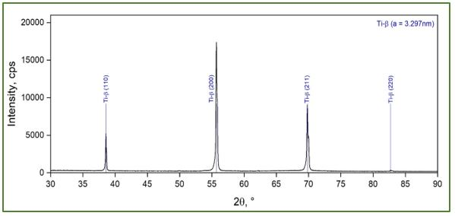
Figure 6. - XRD spectrogram of microstructural state ST1.3 (780°C-30min-CA).

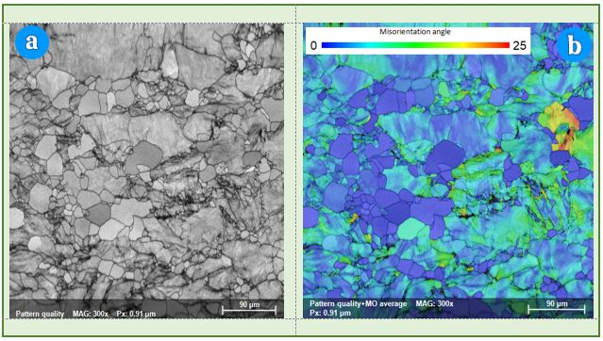
Figure 7. - SEM-EBSD feature image (a) and MO modal orientation distribution map (b) of microstructural state ST1.3 (780°C-30min-CA .

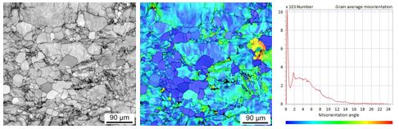
Figure 8. State ST1.3 (solution quenching) -

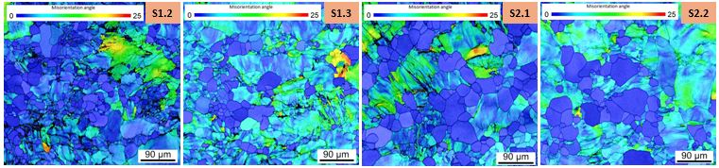
Figure 9. Microstructure evolution of secondary processing

11.1.8 For the best processing version of TNZT-O titanium alloy, ST1.3 condition (780°C - 30 min - AC), the mechanical characteristics are as follows:
Ultimate tensile strength (Rm): 640.91 MPa → Indicates good resistance to mechanical stress, suitable for biomedical applications.
Yield strength (Rp_{0.2}): 528.95 MPa → Represents the strength of the material before permanent plastic deformation.
Modulus of elasticity (E): 52 GPa → Low value, very close to that of human bone, which reduces the risk of stress shielding (stiffness difference between implant and bone).
Elongation at break (A5): 15.75% → A ductility high enough to allow deformation without excessive brittleness.
(chapter 4/paragraph 4.3)

Table 1. Mechanical property values determined for all tested samples
Sample no. |  | Breaking strength | Flow limit (Offset 0,2 % Young) | Module  (Young Automat) | Flow limit (offset 0.2 Emodulus) | Mode of elasticity | Elongate | The strain hardening exponent at n (Automat) | Coefficient of resistance at n (Automat)
 |  | (MPa) | (MPa) | (GPa) | (MPa) | (GPa) | (%) | (/) | (MPa)
S1 |  | 537,16 | 412,54 | 60,69 | 424,57 | 55,17 | 35,48 | 0,1252 | 779,56
S2 |  | 588,09 | 498,31 | 62,39 | 528,52 | 53,3 | 16,79 | 0,0943 | 841,86
S3 |  | 600,51 | 499,86 | 67,63 | 536,97 | 56,39 | 17,08 | 0,0687 | 773,11
S4 |  | 978,65 | 731,13 | 70,11 | 835,14 | 59,21 | 4,25 | 0,2611 | 2598,7
ST1.1 |  | 694,72 | 517,46 | 80,71 | 540,79 | 69,81 | 15,10 | 0,1201 | 997,73
ST1.2 |  | 632,02 | 541,97 | 67,18 | 576,51 | 57,41 | 18.94 | 0,0957 | 922,35
ST1.3 |  | 629,32 | 525,56 | 62 | 570,78 | 52,08 | 14,25 | 0,0718 | 828,08
ST2.1 |  | 636,34 | 541,11 | 68,86 | 578,24 | 57,94 | 19,57 | 0,0635 | 811,75
ST2.2 |  | 645,34 | 577,52 | 69,98 | 603,92 | 61,52 | 14,35 | 0,107 | 1006,51
ST2.3 |  | 688,51 | 545,97 | 78,86 | 571,34 | 69,24 | 13,29 | 0,0895 | 928,49

11.1.9 Comparing the TNZT-O alloy in the optimum state (S1.3: 780°C - 30 min - CA) with other biocompatible alloys, the following significant differences are observed:
(a) Rm=500MPa; E=63GPa for the Ti-35.3Nb-7.1Zr-5.1Ta %wt. [53];
(b) Rm =500MPa; E=65GPa for the Ti-41.1Nb-7.1Zr %wt. [4];
(c) Rm =641MPa; E=52GPa for the Ti-36.5Nb-4.5Zr-3Ta-0.16O %wt. [the new alloy made and stressed in the PhD program];
(d) Rm =755MPa; for Ti-39Nb-6Zr-0.26O %wt. [19];
(e) Rm =851MPa; E=60GPa for Ti-25Nb-17Ta-1Fe-0.25O %wt. [5];
(chapter 4/paragraph 4.3)
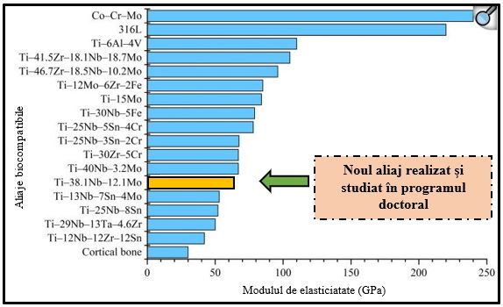
Figure 10. - Comparison of modulus of elasticity between published metastable biomedical titanium alloys, conventional biomedical alloys and cortical bone [218].

11.2 Future directions for scientific research
It was considered that, within the experimental program of the PhD thesis, the exploration at both super- and sub-transus temperatures would have led to a significant increase in the experimental coordinates and the volume of investigations, without bringing sufficient clarification of the studied aspects, if it would have been carried out only in certain experimental coordinates, without a thorough analysis. Given the magnitude of the investigations required, the study of TNZT-O alloy at sub-transient temperatures is a distinct research direction that will require additional effort in a future stage of development
[1] Elahinia MH, Hashemi M, Tabesh M, Bhaduri SB, Manufacturing and processing of NiTi implants: A review. Progress in Materials Science. 2012; 57:911-946.
[2] Kopeliovich D., Titanium Alpha-Beta Alloys; 2018.
[3] Sidambe AT., Biocompatibility of advanced manufactured titanium implants a review. Materials. 2014;7(12):8168-8188.
[4] Yang R, Hao Y, Li S, Development and application of low-modulus biomedical titanium alloy Ti2448. Biomedical Engineering Trends. 2011; 10:225-247.
[5] Hamweendo Agripa and Ionel Botef, Modern Production Methods for Titanium Alloys: A Review, IntechOpen.
[6] M. Peters and C.Leyens, Aerospace and Space Materials. Institute of Materials Research, DLR, German Aerospace Center, (2001), Cologne, Germany.
[7] Banerjee D, Williams J, Perspectives on Titanium science and technology. Acta Mater. 2013;61 (3):844-879.
[8] Sani A. Salihua, Y.I. Suleimanb, A. I. Eyinavia, Classification, Properties and Applications of titanium and its alloys used in automotive industry- A Review, American Journal of Engineering Research (AJER), Volume-8, Issue-8, pp-92-98
[9] Renato Altobelli Antunes, Camilo Augusto Fernandes Salvador, Mara Cristina Lopes de Oliveira Materials selection of titanium alloys for aircraft applications.Materials Research, 21 (2): e20170979, (2018), Brazil.
[10] BirhanSefer, Oxidation and Alpha case phenomena in titanium alloys used in aerospace industry: Ti-6Al-2Sn-4Zr-2Mo and Ti-6Al-4V (published PhD thesis from Lulea University of Technology) (2014).
[11] C. Leyens and M. Peters, Titanium and titanium alloys. Wiley-VCH, Germany
[12] Malis Krishna Krishna Prasad Reddy, Ramawath Prashanth Naik, Madhukar Samatham, Chelluboina Harish Kumar, Review on different welding techniques of Titanium and its alloys, International Journal of Scientific Research in Science, Engineering and Technology, 2020, 7, 1, 2394-4099, (2001).
[13] Ankem S, Greene CA, Recent developments in microstructure/property relationships of beta titanium alloys. Mater Sci Eng, A 1999;263:127e31. https://doi.org/ 10.1016/s0921-5093(98)01170-8.

